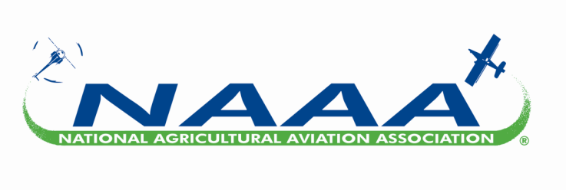
Voice of the Aerial Application Industry
Fact Sheet

Aviation Safety Aspects of Agricultural Aviation
The aerial application industry takes safety very seriously. There are 1,560 aerial application businesses in the United States and about 3,385 working ag pilots who individually averaged flying 334.5 hours in 2021. That’s more than 1.1 million hours flown per season by all ag pilots. Aerial application business owners have an average of 25.7 years of agricultural flying experience and more than 10,000 hours of agricultural flight time logged. In the unfortunate event of an ag aviation accident, ag pilots review accident cases during the PAASS Program, an industry-wide training and safety education forum that 1,700 ag pilots attend each year so they can learn from such incidences and hopefully prevent accidents in the future.
- Safety is an aerial applicator’s top priority.
- Aerial applicators must obtain a commercial pilot’s license and receive medical clearance before they can fly. Moreover, all ag pilots must receive a pesticide license from each state they fly in demonstrating their knowledge in the handling and application of crop protection products.
- All commercial agricultural aviation operations are required to have a Chief Supervisor who must pass a knowledge and skills test administered by an FAA Aviation Safety Inspector. The FAA’s endorsement allows the Chief Supervisor to qualify his/her own company pilots as Pilots-in-Command for aerial applications.
- NAAA educates all aerial applicators year-round about safety issues in the Professional Aerial Applicators’ Support System (PAASS) and other safety programs. The goals of PAASS are to educate pilots on aviation safety, application accuracy and security issues.
- PAASS benefits the aerial application industry by improving the understanding of how human behavior affects safety, enhancing critical aeronautical decision-making skills and emphasizing best practices. The rate of ag aviation accidents has decreased by 25.3% since PAASS was introduced in 1998, proof the program is meeting its goals.
- The Fly Safe Campaign reiterates key safety messages articulated during the PAASS Program. Ag pilots receive regular safety alerts and reminders throughout the flying season from NAAA. Those safety messages go to all ag pilots and aerial application businesses, whether they are members of NAAA or not. This is in keeping with the PAASS credo, “Upon the Performance of Each Rests the Fate of All.”
- According to data from NTSB and FAA, the average accident rate for ag aviation from 2015 to 2019 was 6.68 accidents per 100,000 ag hours flown and the fatality rate was 0.96 fatal accidents per 100,000 ag hours flown. The ag aviation industry’s accident rates are comparable to non-commercial general aviation.
- Many aerial applicators have introduced the “First Response: Responding to a Pesticide-Related Aircraft Accident” video to first responders. The video includes a training guide, copies of a typical chemical label and Material Safety Data Sheet, and a first responder’s guide to handling an ag aircraft accident.
- Aerial application aircraft offer protection and good visibility for the pilot. They are ruggedly built to handle up to 100 takeoffs and landings a day from rough landing strips. Ag aircraft are built to increase the survivability of the pilot in the unlikely event of a crash. Many are also equipped with airbags; all have harnesses and ag pilots commonly wear flight helmets to maximize their safety.
- Ag aircraft utilize GPS to ensure precise applications, and 33% are already equipped for FAA’s next generation of air traffic control, even though most are not required to be because of the rural areas in which they fly.

For more information, contact:
National Agricultural Aviation Association
information@agaviation.org
(202) 546-5722

